Stock Price Prediction Using Machine Learning

By

***21781A33C4 (R Pavithra)***

***21781A33D0 (S Soniya)***

***21781A33D1 (Sanjana K)***

***21781A33E9 (V Naga Shanthi)***

*Guided by*

***Prof. Ms Raasha***

A Dissertation Submitted to

SRI VENKATESWARA COLLEGE OF ENGINEERING AND TECHNOLOGY, An Autonomous Institution affiliated to ‘JNTU Ananthapur’ in Partial Fulfilment of the Bachelor of Technology (***Computer Engineering***) with Specialization in ***Artificial Intelligence and Machine Learning.***

*May 2024*



**SRI VENKATESWARA COLLEGE OF ENGINEERING AND TECHNOLOGY**

**R.V.S. Nagar Tirupathi Road, Andhra Pradesh– 517127**

***Data Collection & Preparation***

DL depends heavily on data. It is the most crucial aspect that makes algorithm training possible. So, this section allows you to download the required dataset.

### ***Collection Of The Dataset***

There are many popular open sources for collecting the data. Eg: kaggle.com, UCI repository, etc.   
 In this project, we have used .csv data. This data is downloaded from kaggle.com. Please refer to the link given below to download the dataset.   
   
As the dataset is downloaded. Let us read and understand the data properly with the help of some visualization techniques and some analyzing techniques.   
 Note: There are a number of techniques for understanding the data. But here we have used some of it. In an additional way, you can use multiple techniques.

**DATASETS**

**AMD:**

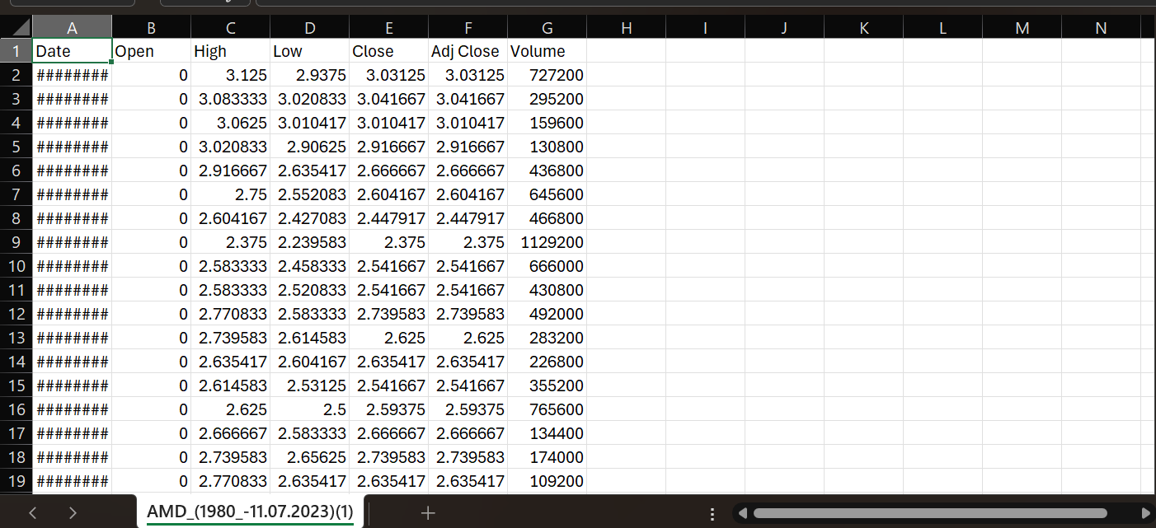

**ASUS:**

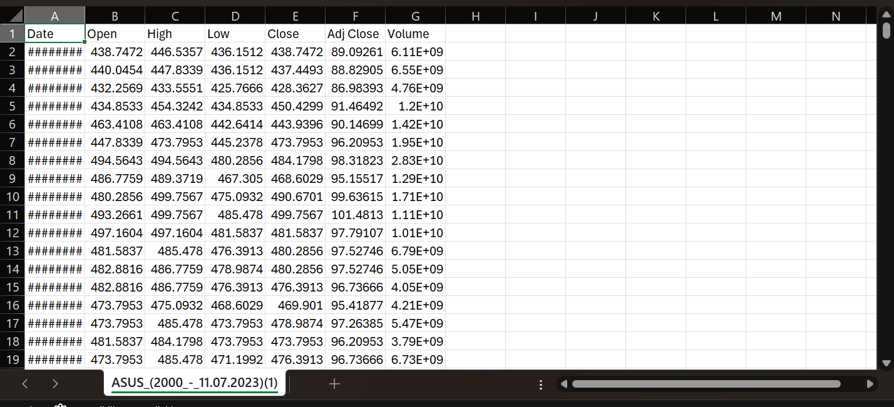

**INTEL:**

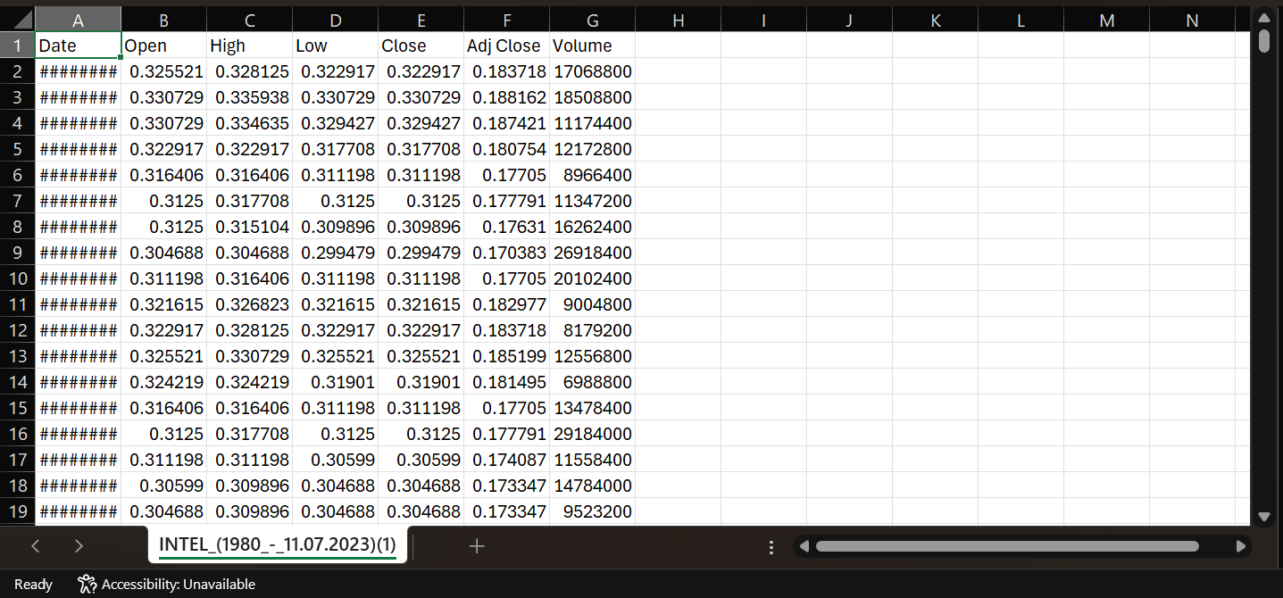

**MSI:**

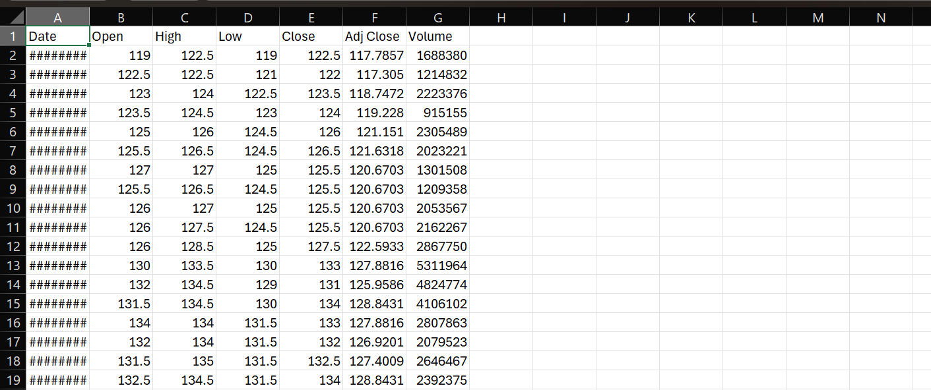

**NVIDIA:**

